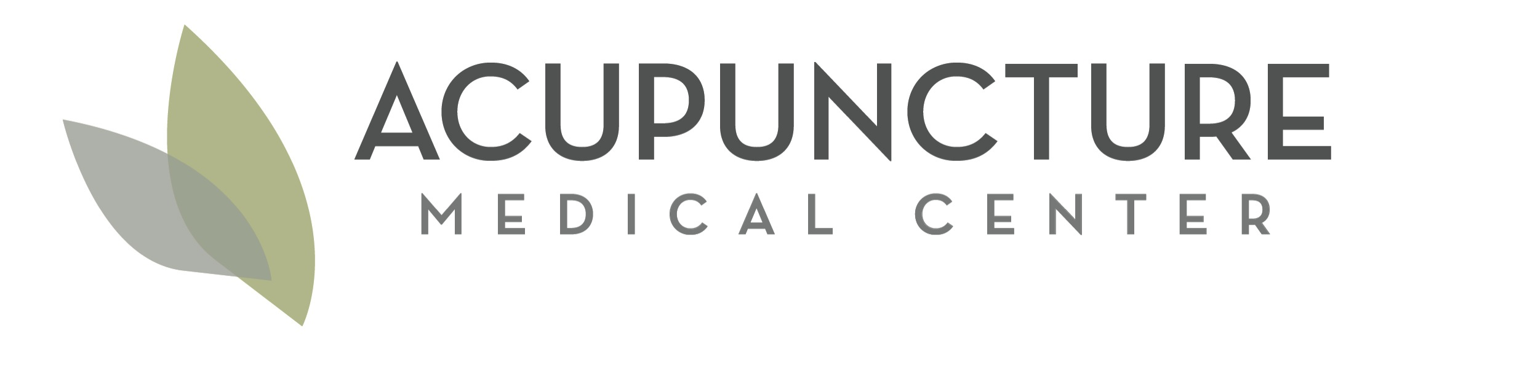
Please help us give a warm WELCOME to:

Linda Banh, our new Associate Acupuncturist!

Linda is a California Licensed Acupuncturist and a native Californian. Her passion for helping others to lead happier and healthier lives has been central to her medical school postgraduate studies and clinical experiences. Linda is here to help others to be well naturally by strengthening her patients’ physical functions and emotional wellbeing with acupuncture, nutrition, and Asian herbs. Linda also brings to the clinic her strong expertise in pharmaceutical drugs and their actions on the body and in how Asian herbal treatment is used very effectively in conjunction with and as a replacement for many common western drug therapies. Linda balances her life by enjoying nature hikes and traveling with her husband Mike. She practices medicine every day with a joy that is rooted from her own experiences with this World Heritage Medicine and is very excited to help this community live happy healthy lives naturally.

